


GLA end of Project Survey

The survey was carried out on 16th December

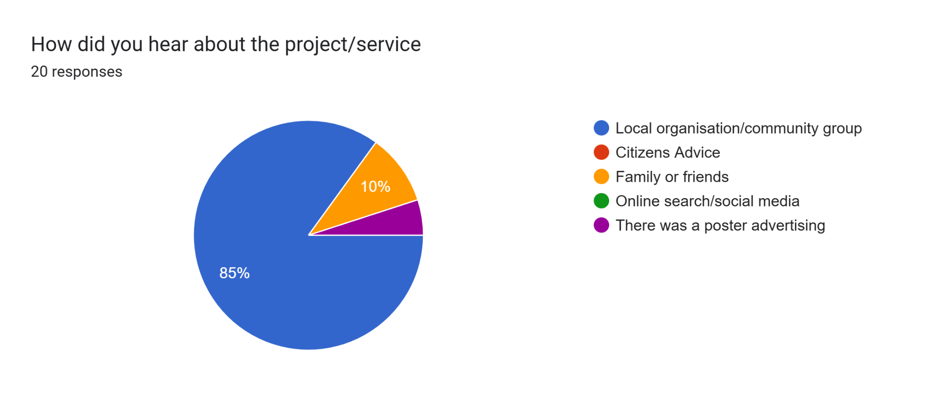

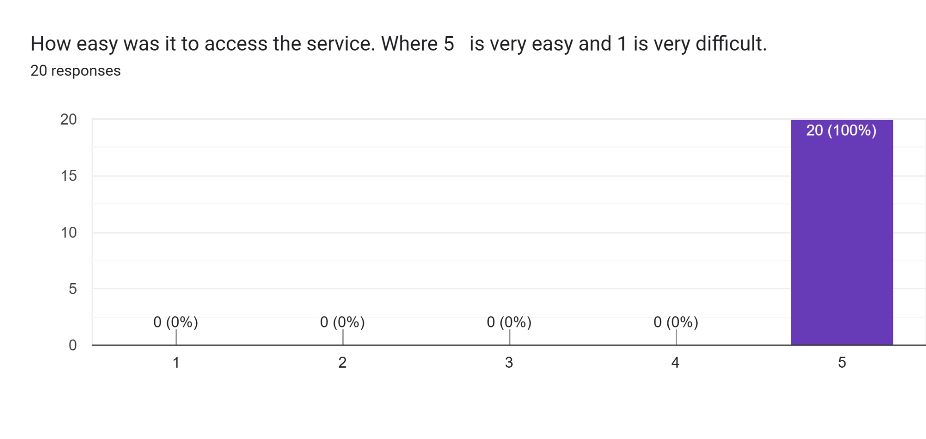

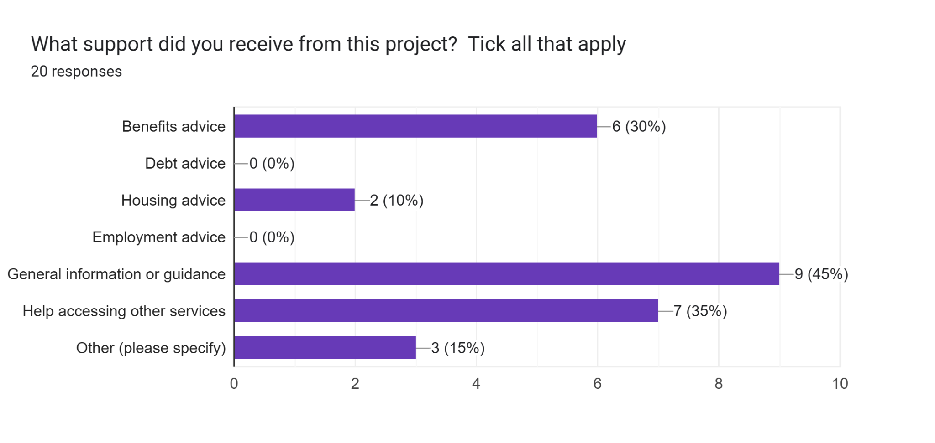

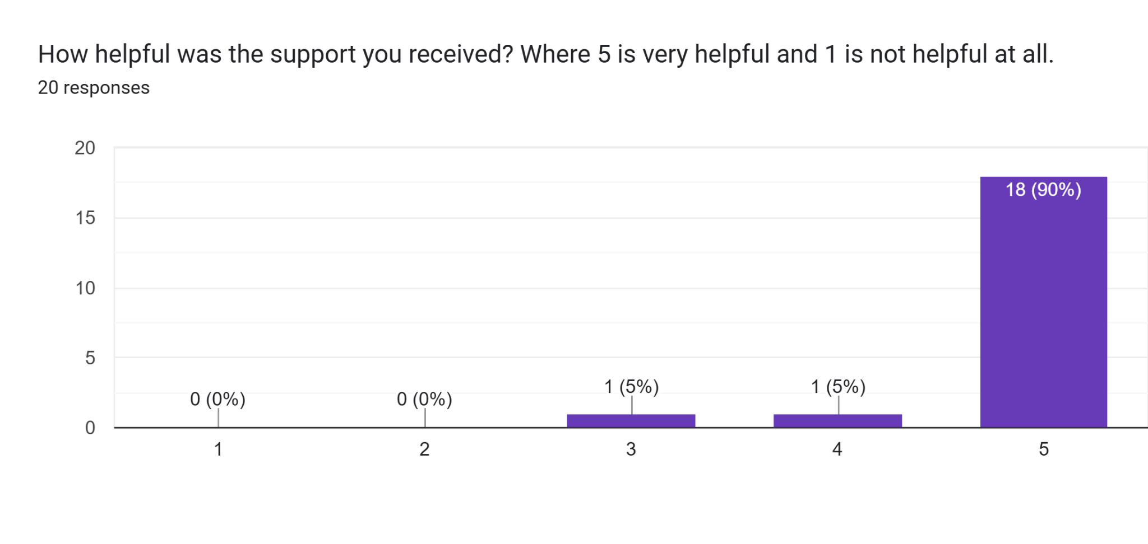

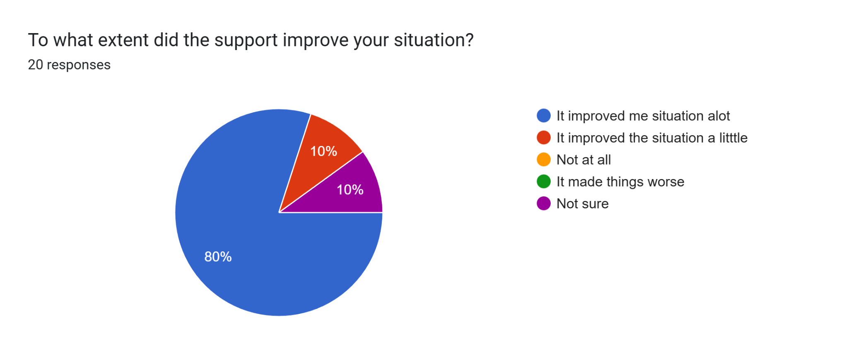

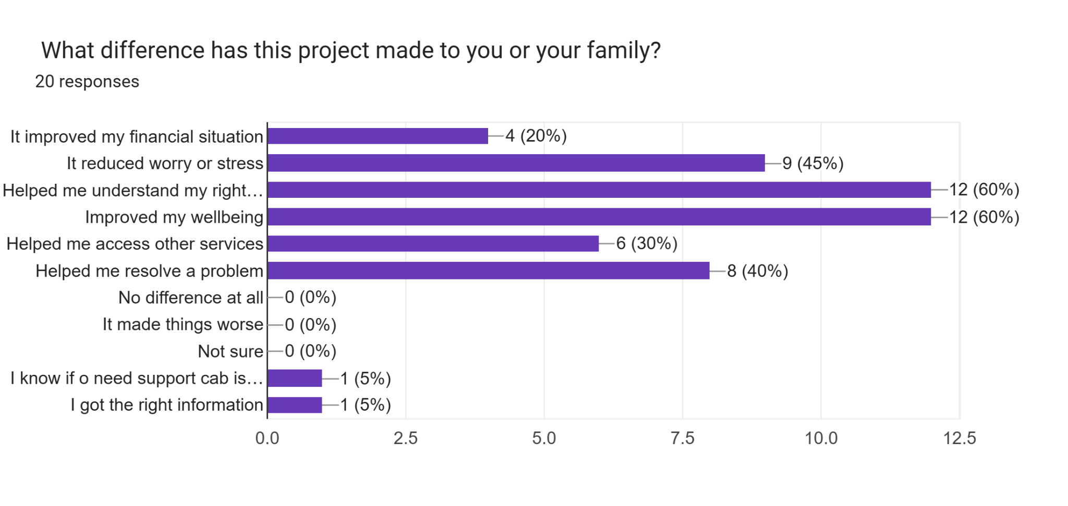

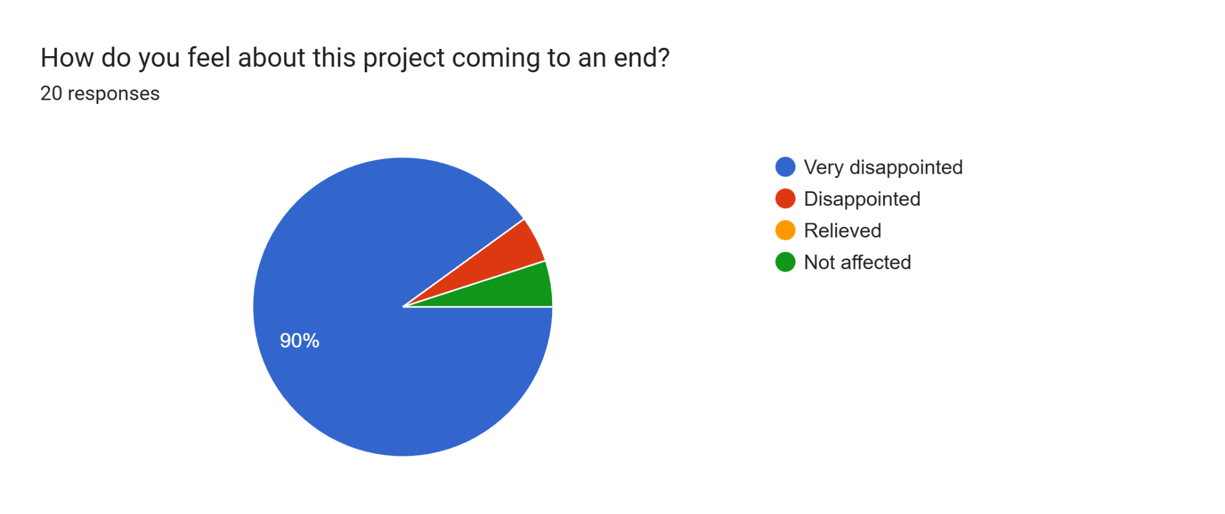

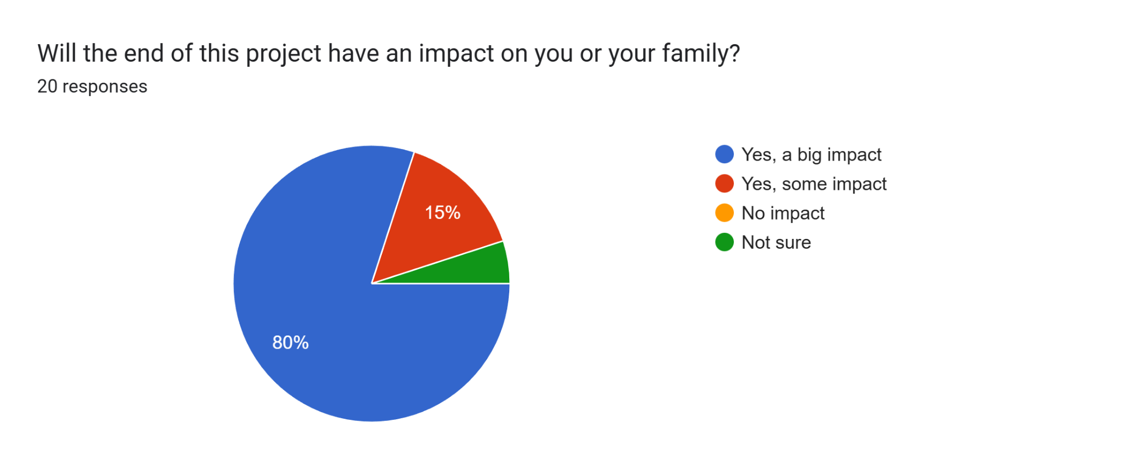

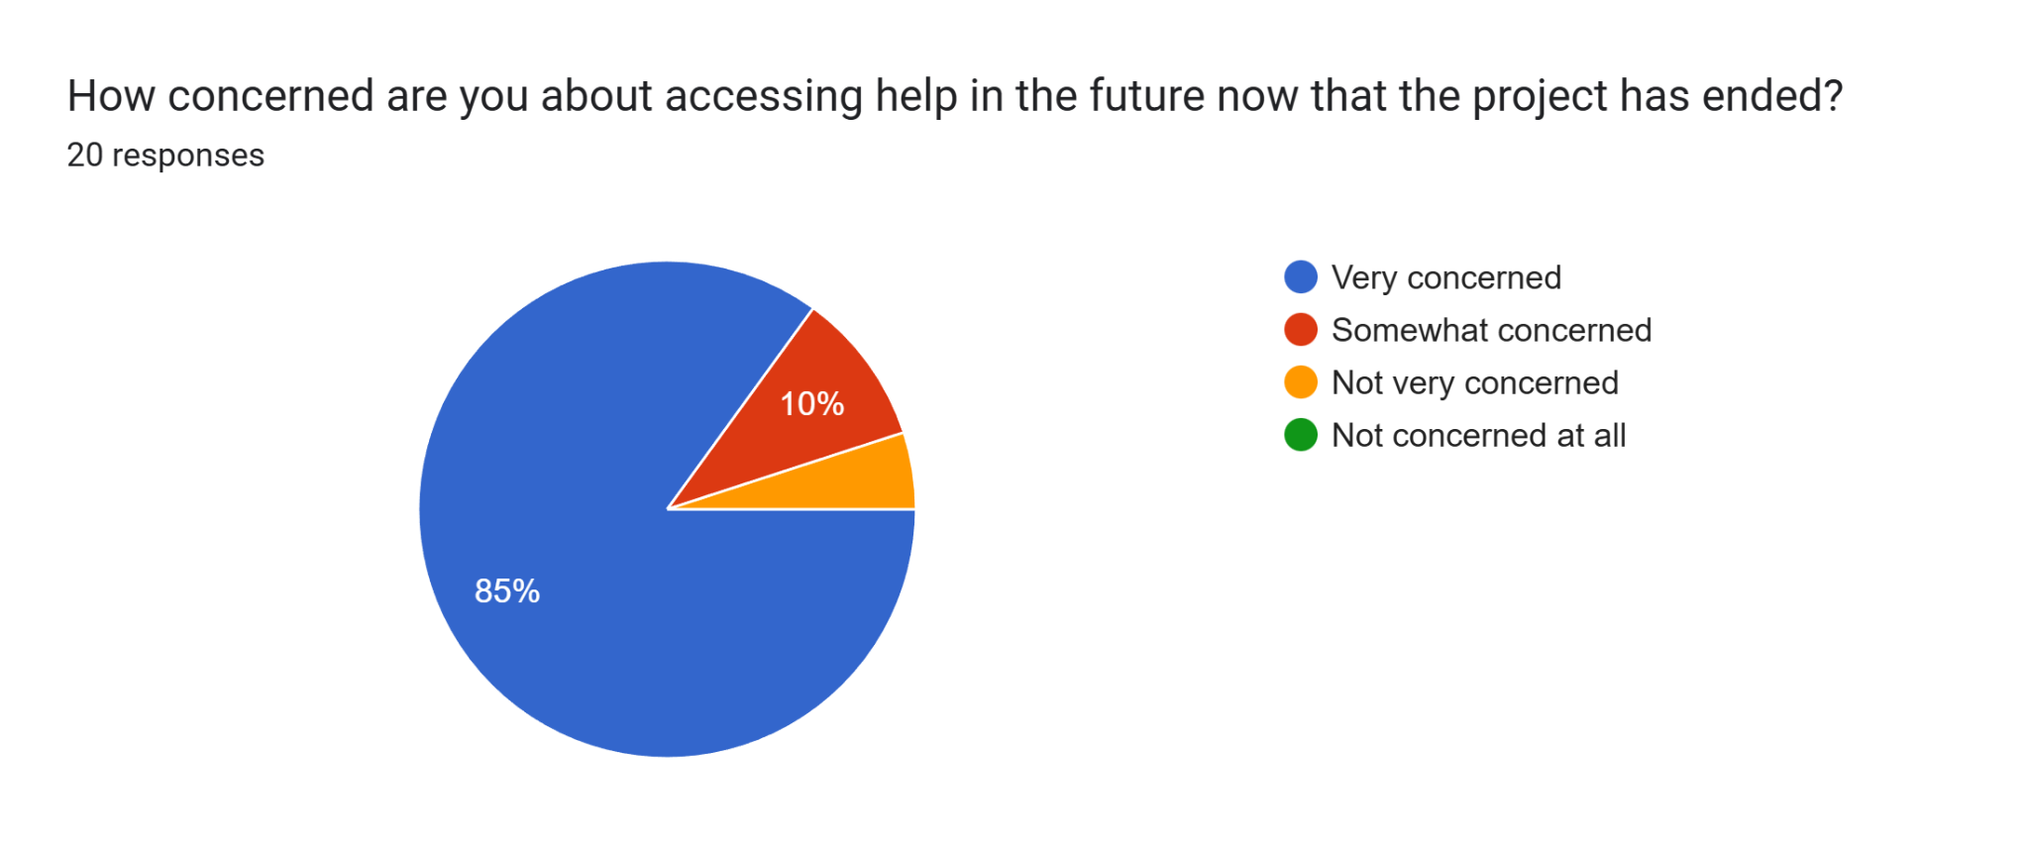

Comments

What could we do to improve in the future

Not to cancel the gla project at hanualt it's a great project
Continue the service
To maintain the service as it was very convenient to access and knowing it was there was really important.
To carry on with the project
Continue service
Funding is imperative for the services to continue
To make accessible
We don't want the GLA hanualt advice service to end
More 1to1 talk
The service you provide is very important for me. I am very happy and grateful about the helpful services you provided me.
To extend the funding
To continue the service at the hanualt outreach especially for elderly
Everything was on point nothing to improve

Is there anything you would like to say about the project ending or share your experience

Would prefer it to continue
My experience accessing the service was extremely helpful. Now it’s ending it will be difficult to access either by phone or physically impossible as there are no nearby CAB sites.
Please continue with the project
Keep the service
Done want it to end
Became a new member of the community and would like to keep the service going
Would like to say that I would be very upset if this ended as I’ve seen young and elderly alike come in very worried or upset and leave more settled
Citizen advice has been amazing and a good service we need
We need easy access and having CAB helps us alot for the elderly
This service shouldn't stop it's very much needed
Try the best to keep it going with all the support from us.
I am really worried about this service coming to an end. I wish the service to continue for few more years.
It was very helpful to have the GLA advisors at hand and it such a shame that the project had ended
Reshma the adviser has been invaluable and sje is part of pur family
Very professional service, I’m very sad the project is coming to an end we need more services like this

